Trophy History, Awarding Rules &
List of Winners
POPS “Crystal Plate” Trophy
History
The Crystal Plate Permanent Trophy was created by Lamberto Serenelli,
WTP # 7, who aimed to highlight the Team, entirely composed by Skydivers Over Sixty, that obtains the best result in the 4-way National Team Competition at the World POPS Meet & Championships.
The Trophy was firstly awarded at the 10th World POPS Meet &
Championship held in Reggio Emilia (Italy) in year 2010; Team “USA SOS XP” (Edwin Miller-Captain, Harry Hopkins, George Nisson, Bruce Travis, Jim Stengell-Camera Flyer) was the winner.
The list of all Winners is enclosed to this document and will be progressively updated by the Managing Committee.

Trophy Managing Committee

The Managing Committee has the tasks to (a) update the section “Winners” of this document, recording there the name of each winning Team as well as those of the Team components and (b) deliver the updated document to both the captain of each winning Team and the World Top Pop that organizes the subsequent Meet for being published on the Meet Web Site.
The Managing Committee is composed by Lamberto Serenelli WTP # 7 (lamberto.serenelli@tin.it) - Chairman and by Italy’s Top Pop, at present Bruno Imberti (bruno.imberti@libero.it) - Secretary.
Awarding Criteria
The official final result of the 4-way National Team competition at the World POPS Meet and Championships must be considered.
If the competition has a separate and official classification for S.O.S. Teams, the Trophy is awarded to the Team winner in such classification; if the competition has only a single overall and official classification including all competing Teams irrespectively of age, the Trophy is awarded to the Team entirely composed by Skydivers Over Sixty that has obtained the best final score in such overall classification.
All components of the winning Team must be members of their Country POPS Organization.
If the competition has no Teams satisfying the above-mentioned rules, the Trophy is not awarded and it is kept by the captain of the last winning Team until the next Meet.
Differently from FAI rules and on consideration that at the World POPS Meet & Championships competition the National Teams Camera Flyer are sometimes provided by the Organizer, citizenship and age of the Team Camera Flyer are not relevant for what concerns the rules of this Trophy.
The captain of the winning Team is responsible of the Trophy preservation as well as of making it available at the location of the next Meet, until its delivery to the next Winner.
As a sign of continuity, at the closing Ceremony of each World POPS Meet and Championships the winning Team Captain receives the Trophy from the Captain of the previous winning Team. In case of absence of the latter and in decreasing order of priority, the Trophy is delivered by one of the previous Team Members, by the Top Pop of their Country, by the WTP in charge.
It is advised that the Trophy is suitably exposed at the D.Z. during each Meet.
The Trophy
The Trophy is composed by a round Crystal Plate, with a diameter of approx. 370 millimetres. In its central part the POPS Logo is reproduced, encircled by the inscriptions in capital letters “SKYDIVERS OVER SIXTY” at the upper side and “S.O.S.” at the lower side; at both ends, the two inscriptions are separated by three stars.
The Plate is completed with a stand, suitably arranged for holding it in upraised position for exhibition purposes and with an updated copy of the present document.
The Trophy is represented in the following picture.
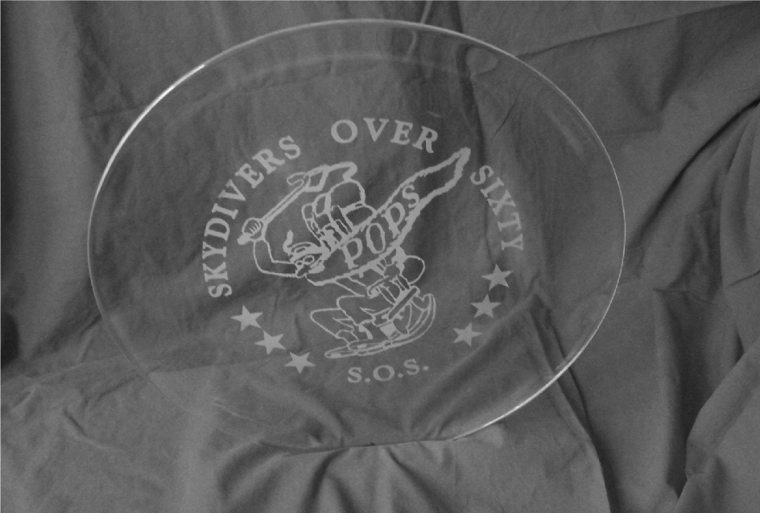

Winners
At the 10th World POPS Meet & Championship (2010) held in Reggio Emilia (Italy) the Trophy was awarded to Team “USA SOS XP” (U.S.A.) composed by Edwin Miller-Captain, Harry Hopkins, George Nisson, Bruce Travis, Jim Stengell - Camera Flyer.
At the 11th World POPS Meet & Championship (2012) held in Teuge (Holland) the Trophy was awarded to Team “SIOLFUR 330” (U.K.), composed by Neils Hansen-Captain, Jeff Chandler, Freddy De-man, Chris Shaw-Competitor and Coach, Ian Nicholson - Camera Flyer.
At the 12th World POPS Meet & Championship (2014) held in San Juan (Argentina) the Trophy was awarded to Team “SOS Swiss” (Switzerland), composed by Bruno Berger -Captain, Hanspeter Schmid, Max Oberli, Andreas Franz.
At the 13th World POPS Meet & Championship (2016) held in Eisenach (Germany) the Trophy was awarded to Team “PARANODON” (Germany), composed by Robert Troegele -Captian, Ulrich Sehrbruck, Hans-Dieter Pfeifer, Jan Rojek and Wolfgang Hagedorn (Camera Flyer)
At the 14th World POPS Meet & Championship (2018) held in Nagambie (Australia) the Trophy was awarded to Team “PARANODON” (Germany), composed by Robert Troegele - Captain, Ulrich Sehrbruck, Hans-Dieter Pfeifer, Martin Strohmeyer and Ralph Speicher (Camera Flyer)
At the 15th World POPS Meet & Championship (2022) held in Netheravon (United Kingdom) the Trophy was retained by Team “PARANODON” (Germany), composed by Robert Troegele - Captain, Ulrich Sehrbruck, Jan Rojek, Josef Kampmann and Wolfgang Hagedorn (Camera Flyer)

SOS Crystal Plate Award Creation and Amendment Record
Original document created and prepared by Bruno Imberti, bruno.imberti@libero.it
Updated 2018 by Volker Cornils, WTP#10
Updated 2022 by Simon Donnelly, UK TOP POP #12

