POPS “PERSONALITY PLATE” AWARD
Pat Moorehead, Committee Chairman, 1 July 2000

HISTORY:

The POPS Personality Plate was first awarded at the 3rd World POPS Meet in Empuriabrava, Spain, in September, 1995. It was a surprise addition to the Awards Banquet ceremonies and was created by the DZ Management and hosts of the meet. The first recipient, at that meet, was Robert ‘Bobby-V’ Valenzuela from the USA. A complete list of subsequent recipients is at the end of this document.
ELIGIBILITY CRITERIA:

It was the intention of the DZ management in Spain that the award recognizes and honors a participant who was most representative of the “POPS Spirit.” This is defined as a singular person who contributes to the overall fun and competitiveness of the meet, is supportive, cooperative, pleasant, and, perhaps, colorful in demeanor.
Eligible individuals may include any member of POPS that is present and participating in some way. This would include, but is not limited to, competitors, Top POPS, World Top POPS, judges, pilots, DZ staff, scorekeepers, manifesters, POPS wives, friends, family members, and non-jumpers. BUT they MUST be a member of POPS. This award is not meant to recognize someone for long-term involvement - but for involvement in the current World POPS Meet only.
Non-eligible people include local politicians, non-POPS, ‘friends’ of the meet management, etc.
SELECTION PROCESS:

The meet management is solely responsible for selecting the recipient. Meet management may, if absolutely necessary, consult with the World Top POP or other Top POPS for advice and guidance. Deviation from the above eligibility criteria may be acceptable if agreed upon by a committee made up of the current World Top POP, all other Top POPS present, and the meet management. It is important, however, that the final selection is made by the meet management alone. The name of the recipient should not be revealed until the final awards banquet.
PRESENTATION PROCESS:

The previous recipient of the POPS Plate should be called to the stage at the awards banquet. As this plate may be unfamiliar to new POPS and others, he or she will raise the plate high for all to see as the Staff representative explains to the audience the history, eligibility criteria, and selection process. When the new recipient is announced and comes to the stage, the previous winner will hand the plate to them then step back or leave the stage. The appropriate photos will be taken with the staff and the new recipient.

NOTE: Should the previous recipient be unable to attend, a staff member will display and present the plate to the new winner.
THE TROPHY:

The original silver plate, contributed by Spain, is a “perpetual” trophy. Each recipient is obligated to have the appropriate information engraved on the plate and then bring or deliver it to the next World Meet. If the recipient wishes to keep a souvenir plate (of any size) for their personal collection, it is their responsibility to have a plate made at their own expense.
There is no budget in the POPS organization regarding this award. It is expected that the World Top POP may incur some minor expenses such as postage, phone calls, etc., in the administrative duties regarding the award.
If this historical plate is somehow lost, the person who was in possession of the plate at that time is obligated to replace the plate, including all engravings.
Once there is no more area on the front of the plate for engraving, the plate will be retired to a suitable location for proper display (possible to the Empuriabrava DZ where it originated, possibly to a future POPS museum). It will then be the responsibility of the current World Top POP to provide a similar plate of equal size and value so that the tradition may continue.
The recipient of the plate at the World Meet will be given a copy of these rules when given the award so that there is no misunderstanding the importance of the plate and their responsibilities listed hereon.
Each World Top POP shall provide his/her successor with a copy of these rules.
RECORDS:
All records regarding this award will be kept by the following: 1. The current World
Top POP, 2. The recipient, 3. The POPS Historian and, 4. The POPS Awards Coordinator (currently Len Zak). This is to ensure that this award remains an integral part
of all future World POPS Meets. (The Top POP USA, the oldest of the POPS
Organizations, should also keep a copy of this document on file)
The recipient, when possible, is expected to provide a photo of themselves, and the plate, to the above (4) persons for the POPS history files and other records. It is highly recommended that the recipient submits, in a timely manner, a photo and short article to all world-wide parachuting publications.

COMMITTEE MEMBERS –1 July 2001: Pat Moorehead, Len Zak, Karl Poruben, Mike Allum, Shirley Powell, Bobby V., Ted Rose, John Crowhurst, Pete Jones (Empuriabrava DZ).

RECIPIENTS:

1995: 3rd World Meet, Empuriabrava, Spain: Robert ‘Bobby-V’ Valenzuela, Competitor
1997: 4th World Meet, Aqaba, Jordan: Shirley Powell, Manifestor
1999: 5th World Meet, Chilliwack, Canada: The Danish Contingent, competitors.
2002: 6th World Meet, Matamata, New Zealand: Steve McCurley, Chief Judge
2004: 7th World Meet, Gruyeres, Switzerland: Andreas Knabe, Meet Director
2006: 8th World Meet, Skydive Arizona, USA: Bruno Imberti, Competitor
2008: 9th World Meet, Skydive Ramblers, Toogoolawah, Australia: Bernie Shaw, Skydiver
2010: 10th World Meet, BFU Reggio Emilia, Italy: Daniele Bullen, Meet Director

2012: 11th World Meet, Teuge, Netherlands: Henny Wiggers, Meet Director 2014: 12th World Meet, San Juan, Argentina: Norman Forbes, Skydiver and “Ambassador” to the many schoolchildren that came out to see the competition

2016: 13th World Meet, Eisenach, Germany: Bruno Gandziarowski, Captain team SOS-Germany

2018: 14th World Meet, Nagambie, Australia: Michael Lilja, Top POP Sweden
2022: 15th World Meet, Netheravon, United Kingdom: Marine Gaelle Camera and Competitor
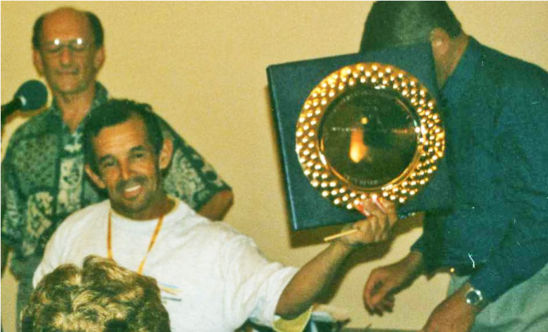

First holder: Robert ‘Bobby-V’ Valenzuela, 1995 3rd World Meet Ampuriabrava.
updated 2022 Simon Donnelly, UK TOP POP #12

